Step1: Create a new personal gmail account and then go to google drive

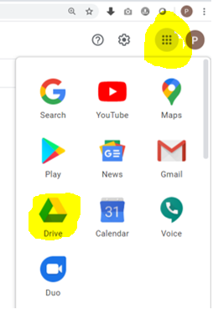

Step2: Go togoogle drive and upload the dataset onto **My Drive**

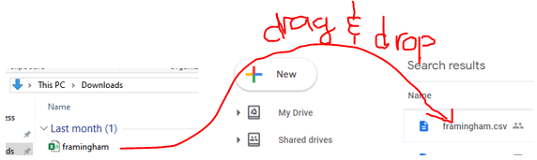

Step3: Ask Michael to add your personal gmail accounts onto the **shared drive** (763ML)

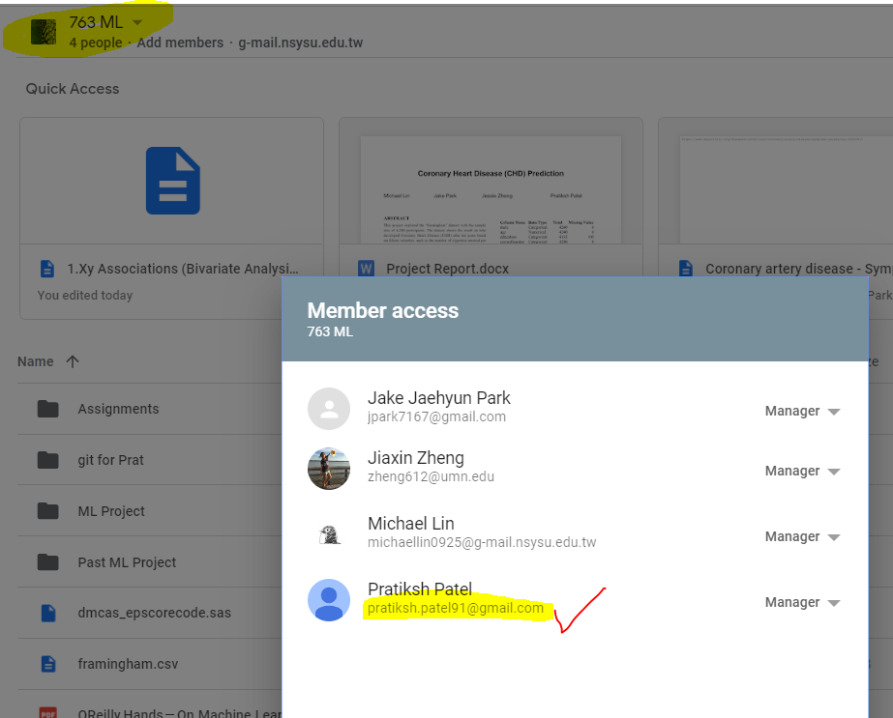

Step4: Dowload Google Colab and connect it to your google drive

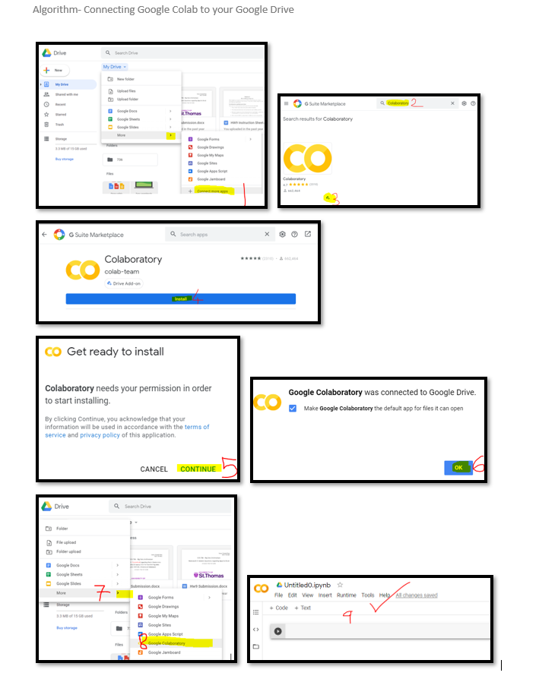

Step5: Click on the **Shared drive** (763 ML) and navigate to the google colab notebooks

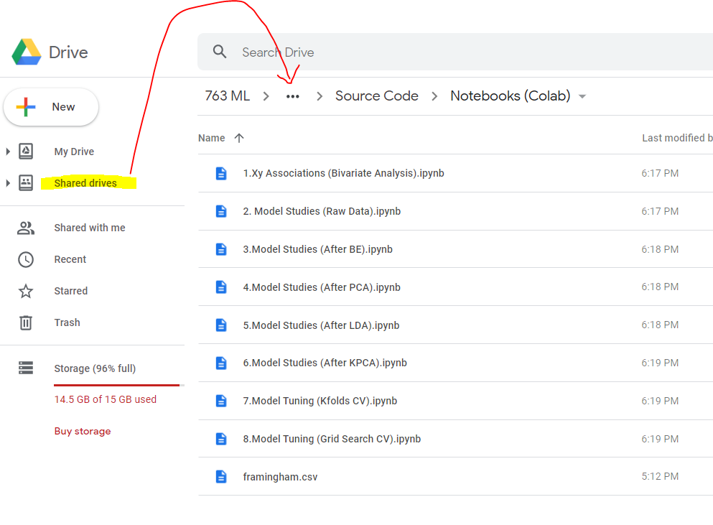

Step6: Click on any of the google colab notebooks and select **Open with Google Collaboratory**

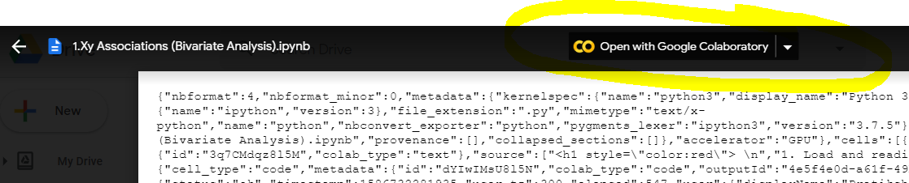

Step7: Verify that you can successfully open the google colab notebook

